Přemysl Hytych was born in a small Czech village Měnín and has been professionally interested in floristry since mid-nineties when he started to build up his career to become the top florist he is today. He has always been fascinated by the creative force of nature, its diversity, shapes and colours. His artwork is affected by his birthplace and country. He uses structure, nature, variety of plants and individual elements of the region into his works.

Přemysl’s artwork is an expression of purity, which he achieves with perfectly balanced compositions, deep sense of detail and variety of colours and materials. As Přemysl draws from his train of thoughts, his works are characterized by considerable originality. Přemysl provokes with this originality and that is one of the reasons he is acclaimed internationally. His floristic artworks were awarded prizes in many national and international competitions.

The most important achievement Přemysl got recently:
2009 Winner of International Floristry Championship in the Czech Republic
2012 International Floristry Championship in Slovakia 1st
2013 Fusion Flowers competition in Scotland, Designer of the Year 2013 1st
2013 Wedding bouquet of Special Flowers in Russia 3rd
2013 International Floral Art 2013/14 (Stichting Kunsteboek, Belgium) Golden Leaf
2014 Winner of International Floristry Championship in Poland
2015 Fusion Flowers competition in Scotland, Designer of the Year 2013 2st
2016 International Floral Art 2016/17 (Stichting Kunsteboek, Belgium) Silver Leaf

He himself has also taught at workshops, seminars, demonstrations and exhibitions in the Czech Republic, Slovak Republic, Poland, Holland, Scotland, Japan and China.

Philosophy of my work
Working with the plant material is like a ceremony to me. I worship every plant and see it as a unique organism that deserves a special place in the object that I create. Each plant is majestical and should be honoured in my work – this is what comes to my mind every time I start something new.
Although I like to combine materials, I believe in simplicity and clean lines. I care very much about my feelings that are interwoven into my work.
Everyday communication with nature is very important to me because I regard Mother as an endless source of inspiration!
Generally I am very interested in observing my surroundings, people and things in it. I like to unite it all together so that it all mutually communicates, nothing is suppressed and to a certain extent they all support themselves.
Above all I try not only to see the materials or colours – for purpose of my work I also need to feel and smell them, because every element I put in my work mirrors a unique essence of life.
I like to look back and draw from traditions and traditional materials, but I always try to grasp and name them differently. Yes, rules are important to me, but I know the rules are there to be violated here and there. Both in life and my work I enjoy balancing on the edge.

My motto: Never hide behind your feelings and do not be ashamed for them because you have a unique opportunity to show the world pieces of your soul.

Mr. Přemysl Hytych

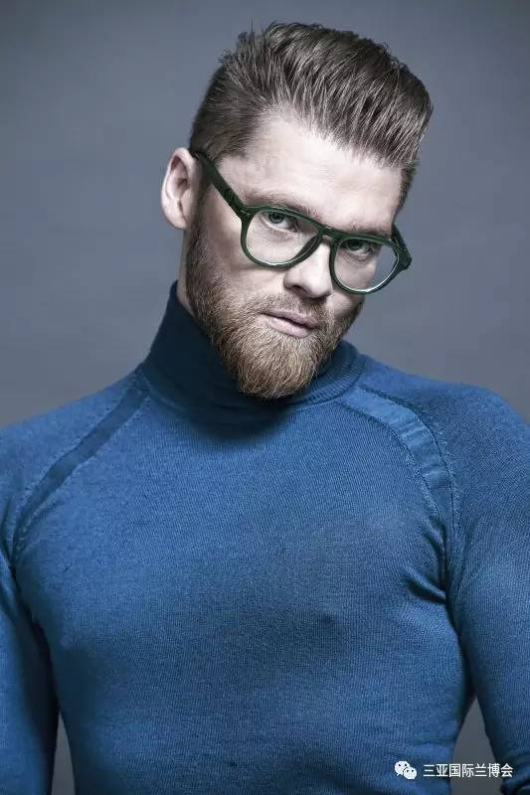

His Works:

